Find Your Next Job Now
series

Questions YOU Ask as a Job Candidate
Week 6 of 9
March 23, 2023

After this session, you'll know:
- Why it’s so important to have questions prepared
After this session, you’ll have these types of questions for interviews:
- What are the most important characteristics for someone in this role?
- Imagine…
- Broad → Detailed
- FUN questions
- Fit and Hesitation question

Senia Maymin, PhD
senia@senia.com
https://www.linkedin.com/in/seniamaymin/
Jobsearch mailing list: www.jobsearch2023.com

Table of Contents

Where We Are 3
Today’s session on
Asking Questions as the Job Candidate 4
1) WHY Have Questions Prepared 4
2) Questions to Ask as a Job Candidate 5
YOUR ACTIONS BETWEEN TODAY AND NEXT WEEK 8
YOUR NOTES 8
How to Get More Info on the #JobSearch2023 Series 10
How to get on the mailing list - we send ALL updates here 10
Are the sessions recorded? Yes, subscribe here 10
Most sessions have a workbook 10

Where We Are
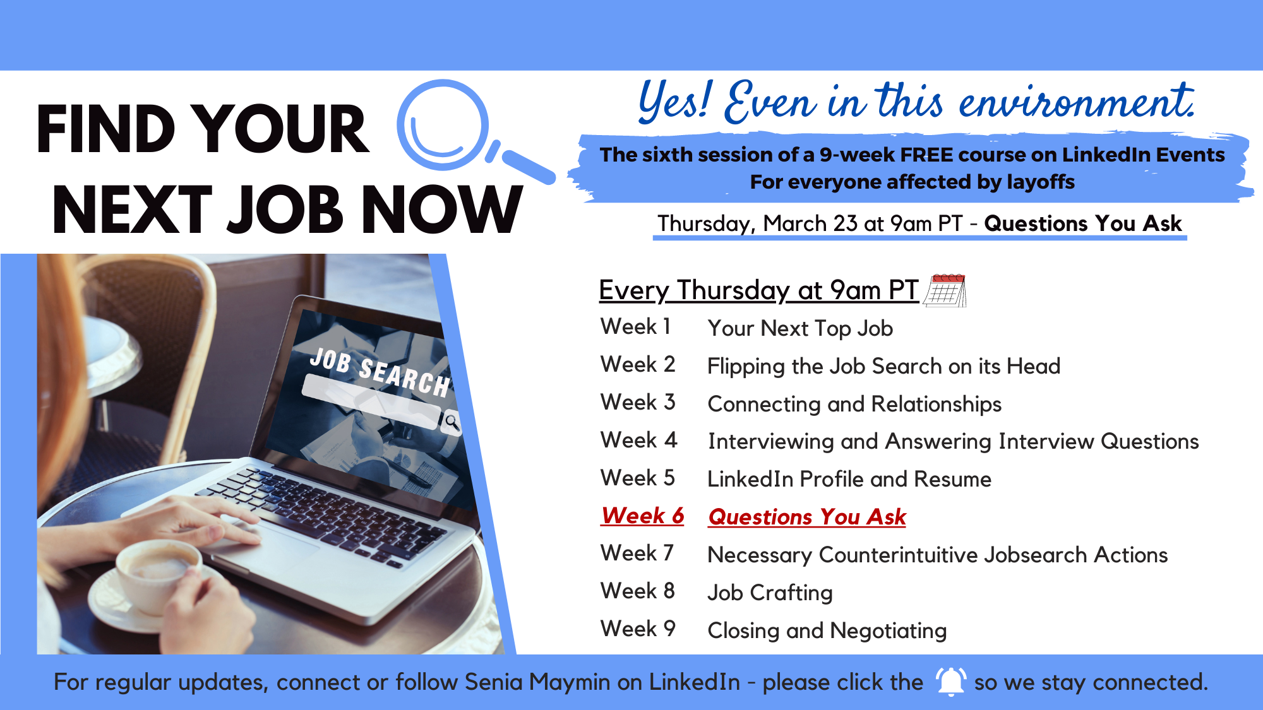

What have you used from the previous sessions?
1 - Reaching out to people? Resting and restring yourself?
2 - You’re a consultant, not a job candidate; look for a job by not looking for a job
3 - Connecting
4 - SARI Stories
5 - Resume and LinkedIn Profile

Today’s session on
Asking Questions as the Job Candidate

1) WHY Have Questions Prepared

- You Are Interviewing Each Other

- It Shows You’re Prepared
- It Shows You’re Interested

- It Makes Conversation Flow

2) Questions to Ask as a Job Candidate
Opening Question for manager

- For this role, it seems like these are the highlights of the role. What are the most important characteristics for someone in this role? What is most important for you about this role in terms of making you and the company more successful?
- What are your expectations for the first 90 days?
________________________________________________
__2. What would be one key that you would like to point out in this role?___________________________________________
________________________________________________
________________________________________________

Feedback reimagined

Imagine…
_Imagine that you determine this is the right fit or imagine that we are working together in 3 months, what our work together would be like in 3 months if we were to be successful? (Pause)

- What would success look like to you in 3 months?

________
What is one aspect of the culture you like and what would you change?_______________________________________
_____What is the dream skill you would like to have present in your daily interaction with the role?
_______________________________________
________________________________________________
________________________________________________
You’ve got to walk out with departmental challenges.

- Broad → Detailed
Company level
- What are the avenues that lead to the success of achieving the company’s success?
- Given the current state of the economy, what challenges is your company facing?
- What would a typical day look like in this role?
Team Level
- How do decisions get made? What can work even better?
- How does your team recognize wins?
- How well does your team work cross-functionally?
- How is the team currently operating and how do you see this role fitting in?
- What are the team’s concerns for the immediate 5 years?
- What would you do differently for a project you did before?
- What are some of the challenges/problems that you are facing or trying to solve?

4. Fun questions
- What is the culture like? Can you share me a story that demonstrates the culture of the company?
- What would you change or augment about this culture?

- What gets awarded at this company? I.e. hero culture - when someone fixes something.
- You’ve been at this company for XXX years. What’s been the most surprising to you?
- What do I not want to know about this role?

- FUN questions
________________________________________________
________________________________________________
________________________________________________
________________________________________________

- Closing Question - Fit and Hesitation question
1. Where do you see there may be a fit?
2. And where might there be some hesitations?
3. May I offer some additional context?

Mini Challenge for You

This week:
Ask some of these questions of your friend to practice.

YOUR ACTIONS BETWEEN TODAY AND NEXT WEEK

What is your ONE TAKEAWAY from today?

Three Actions - Health, Work, Connection

- Health (choose one of the below - yes, one, dear high achievers!)
  - Your sleep action
  - Your exercise action (suggested 30-5-5-5-5)
  - Your water intake and nutrition action
  - Your mindfulness action

- Your incremental action on your job search - the new action
MINI CHALLENGE: Ask a friend some of these questions

- Your connection action
Who do you want to have coffee with?
Go for a walk with?

YOUR NOTES

How to Get More Info on the #JobSearch2023 Series

How to get on the mailing list - we send ALL updates here
www.jobsearch2023.com

Are the sessions recorded? Yes, subscribe here
www.youtube.com/@jobsearch2023

Most sessions have a workbook
- Session 1 has no workbook
- Session 2 workbook - bit.ly/jobsearch2023_week2
- Session 3 workbook - bit.ly/jobsearch2023_week3
- Session 4 workbook - bit.ly/jobsearch2023_week4
- Session 5 workbook - bit.ly/jobsearch2023_week5
- Session 6 workbook - bit.ly/jobsearch2023_week6
- …
- [next ones to be added]

